
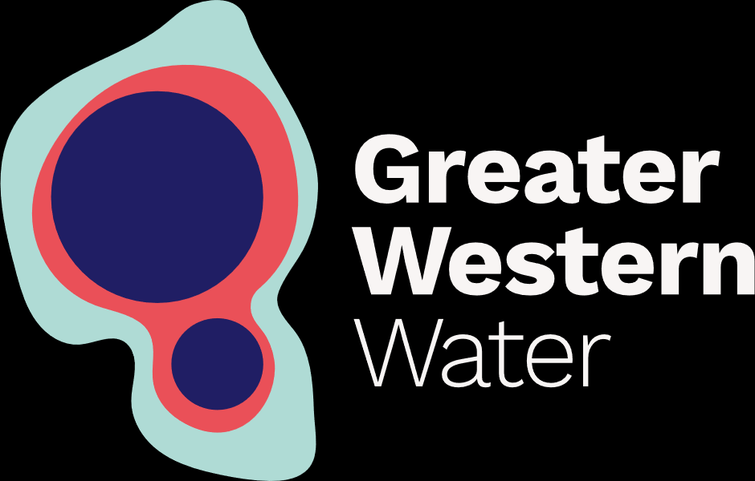

Acknowledgement of Country

Engagement Framework
2026-2030
Draft | June 2025

Greater Western Water respectfully acknowledges the Traditional Owners of the lands and waters upon which we work and operate, the Wurundjeri Woi-wurrung, Wadawurrung, Taungurung, Djaara, and Bunurong peoples. We pay our deepest respects to their Elders past and present who continue to forge the way ahead for their emerging leaders.

We acknowledge the continued cultural, social, and spiritual connections that First Nations people have with the lands and waters. We also recognise and deeply value the care and protection Traditional Owners have brought to Country for thousands of generations.
Our vision is that the way we deliver water services will heal and care for Country, and we are committed to walk alongside and learn from Traditional Owners on this journey.
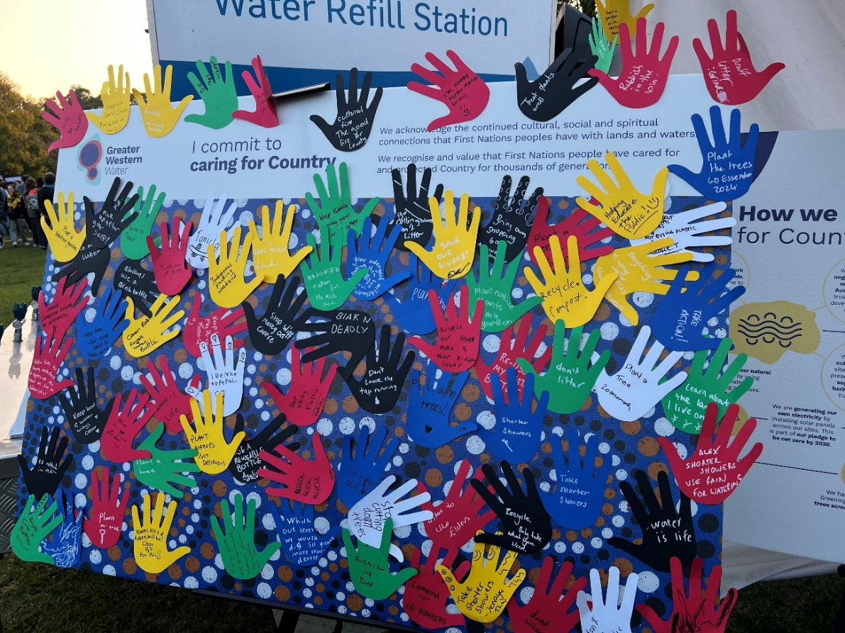

[Foreword to be included September 2025]

About Greater Western Water
Greater Western Water (GWW) provides water and wastewater services to almost 1.3 million people across an area that stretches from Melbourne’s central business district, inner and north-western suburbs through the Melton and Sunbury growth corridors to Bacchus Marsh and the Macedon Ranges.

We strive to:

Deliver value for our customers

Support communities to thrive

Heal and care for Country.

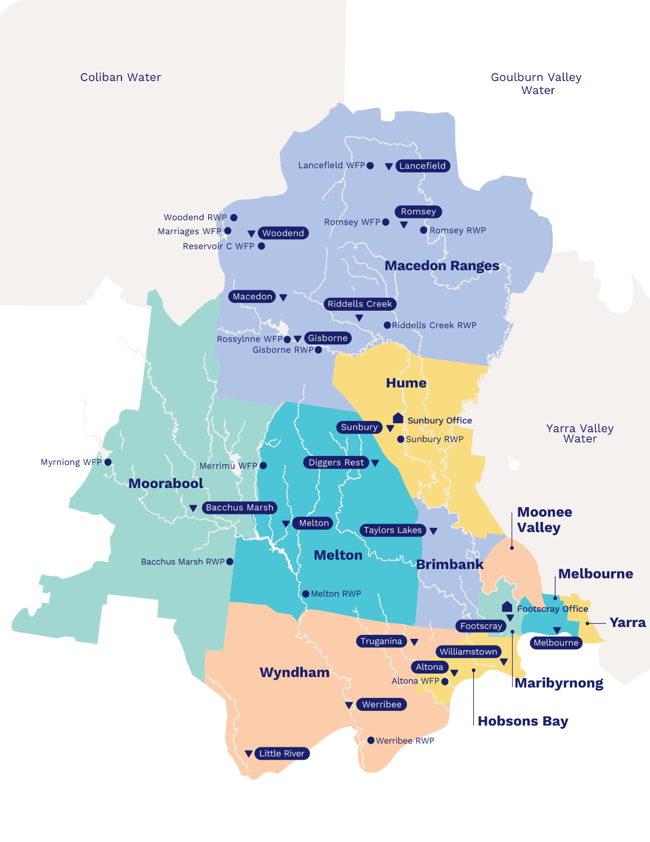

The purpose of this Framework
We want to involve you in the way we work, so we can make better decisions together.
This Framework outlines how GWW will engage with you as a customer, community member or stakeholder.
It tells you what you can expect when we engage with you: how we will give you information, and how we will use the feedback that you give us.

Our principles
Integrity  We protect your privacy. We have a responsibility to hear your views. We report on engagement outcomes without bias. | Respect  We know that everyone has a different perspective, and we welcome all views. | Understanding  We take the time to understand how our projects, programs and services could affect you.
Authenticity  You have real opportunities to influence our work. We are clear on what you can and can’t have a say in. We provide information whenever we can, and we act on your feedback. | Inclusivity  Everyone has a right to be heard. We will provide information in easy-to-read and accessible formats. We will minimise barriers to your participation in our activities. | Connection  We strive to develop strong relationships with customers, communities and stakeholders. We aim to achieve the best outcomes for everyone.

Who we are
[Service area infographic to be updated September 2025]

Who we work with

What is engagement?
At GWW, we think of engagement as:
‘Involving the people who benefit from, or who are impacted by, our projects, programs or services, to help us make better decisions together.'
This means we want to hear from you.
We want you to tell us what matters to you, what you need from us as an essential service provider and how we can support you.
We also want to make sure you know about the services we provide.

What is good engagement?
- When we give you the right information so you can provide feedback.
- When we listen to your concerns.
- When we understand what matters to you.
- When you have enough ways and time to give us feedback.
- When you know what you can and can’t decide or have input into.
- When we act on your feedback as promised.

Why we need your feedback
- You are the expert in your own community.
- Your opinion helps us make better decisions and deliver services that reflect your needs.
- When we work together, we can build stronger relationships to better understand each other.
- By engaging as part of construction planning, we can reduce our impact on your daily life and avoid delays later.
- We also have regulatory obligations to engage, for instance by the Essential Services Commission and the Environment Protection Authority.

Understanding what you can influence
- We seek and listen to your feedback because you have a right to participate in decisions that affect you.
- When we design our engagement programs, we use the International Association of Public Participation (IAP2) spectrum of engagement to help us understand appropriate community and stakeholder influence.
- There are some final decisions that need to be made by technical experts at GWW or by other authorities. When this happens, we do our best to explain why those decisions were made.
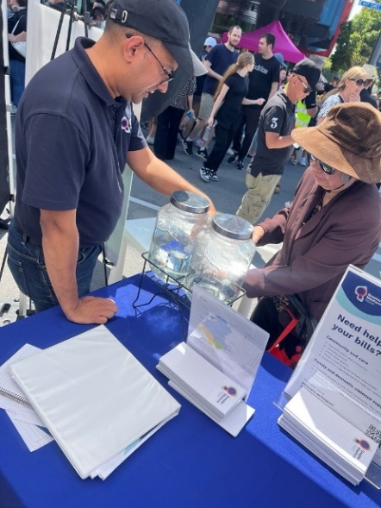
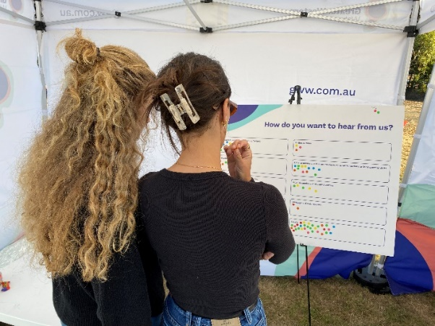
Our commitment to accessible engagement
With your input we can build services that are stronger, more inclusive and more responsive to the diverse communities we serve.
We know that within our service area there are community members who experience barriers to participation in engagement.
These barriers may include speaking in a language other than English, educational disadvantage, having insecure employment, holding caring and work responsibilities, experiencing family violence or having limited access to transport.
We understand that people with disabilities can be uniquely impacted by interruptions to water services, infrastructure projects and organisational policies.
We want to understand our communities and we look for different ways to reach as many people as we can, providing multiple opportunities to engage.

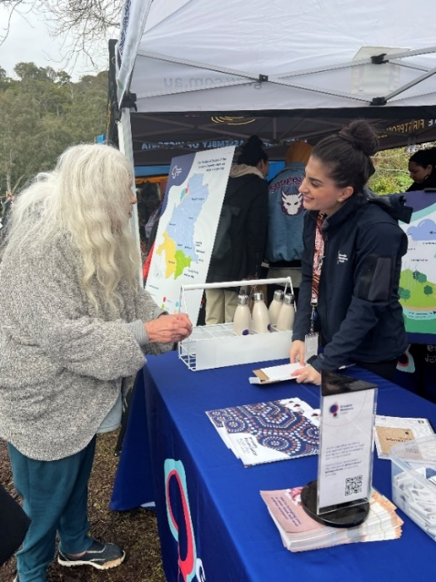

Information in accessible formats
GWW tries to make information available in formats that are easily understood by as many people as possible.
We aim to use Plain English, produce screen-reader friendly documents, keep charts simple and overlay alternative text over images.
We try to have a person-centred approach; meeting people’s needs wherever possible.
We will stay flexible and make information accessible as needed.

Continuous learning and improvement
We know that meeting the needs of diverse communities requires flexibility and ongoing commitment. We will continue to improve how we work with our diverse communities through training, collaboration with community groups and listening to our customers.

Traditional Owner engagement

We will develop our partnership with Traditional Owner groups to ensure their contribution to the future of the water management landscape, and to maintain their cultural and spiritual connection.

We operate on the lands of the Kulin. This represents five nations:
  - Bunurong/Boon Wurrung
  - Djaara/Dja Dja Wurrung
  - Taungurung
  - Wadawurrung
  - Wurundjeri/Woi-wurrung.

Engagement with First Nations communities, including Traditional Owners will:
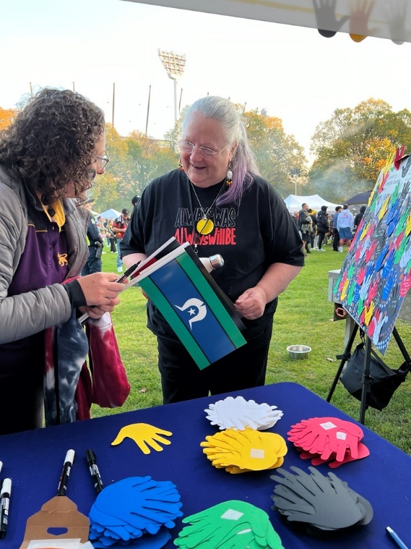
- Be based on their free, prior, and informed consent and reflect their desire and capacity to do so.
- Respect, acknowledge and preserve cultural heritage.
- Recognise and incorporate First Nations people’s knowledge of natural resources into our planning, delivery and operations.
- Have respect for and provide appropriate protection of intellectual and property rights in sharing information.
- Recognise and be reflective of the different needs, aspirations and capability of First Nations communities.
- Be based on collaboration and genuine mutual respect and enable early engagement and co-design.
- Be supported by adequate provision of resources to enable the engagement/partnership of First Nations communities that is commensurate with the level of effort for them to do so.
- Be transparent and include monitoring and mechanisms to report back.

Language support
Our service area represents great cultural and language diversity.
You can access our free translation and interpreter services over the phone. We can support over 300+ languages, including:
- Vietnamese
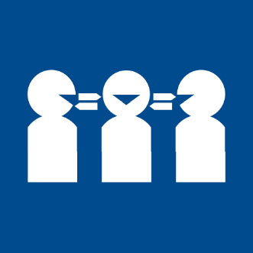
- Mandarin
- Arabic
- Burmese
- Chin Hakha
- Spanish
- Cantonese
- Serbian
- Italian
- Croatian
Access this service at no charge by calling our interpreter line on 03 9313 8989.
The service is available Monday to Friday from 9am to 5pm. Callers outside business hours and during public holidays can still access the service if their call relates to a water or sewerage fault or emergency.

Engagement case studies

2024 Price Submission engagement
What is a price submission?
A price submission is the agreement that GWW makes with our industry’s regulator, the Essential Services Commission. It outlines the prices we will charge, the service customers can expect and the investments we will make in one regulatory period.
Engagement goal
To understand customer expectations and values. Our guiding question was: ‘how do we use the voices and values of our customers to achieve a balance of investment in the future, while maintaining an affordable service?’
What could communities influence?
What GWW would invest in over the next four years (our regulatory pricing period).
What was the outcome?
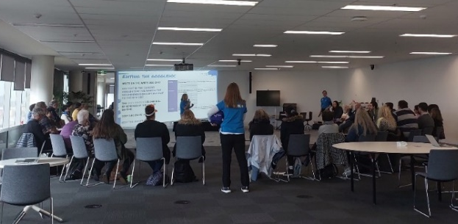
With help from our customers, we developed five customer outcomes that we will focus on achieving for the next four years:
  - Your water is safe, consistent and resilient
  - When things go wrong, we fix them
  - We support our diverse communities and customers
  - We enable growth and help businesses thrive
  - We heal and care for Country.
How did we engage with customers?
Over 18 months, we heard from more than 8,000 customers and community members. Our engagement included:
  - 7,269 survey responses
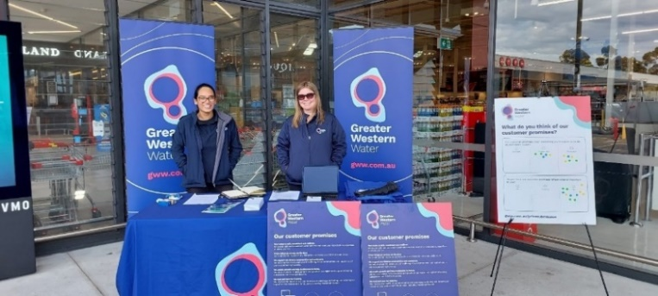
  - 209 attendees to 26 focus groups
  - 19 interviews with key stakeholders
  - Seven pop-up events with a total of 385 attendees
  - A community advisory group
  - A community panel with 44 members, and an ongoing customer forum with 22 members
  - Over 3,000 visits to our online platform YourSay.

Royal Parade water main renewal
What was the project?
Between March 2023 and January 2024 works were undertaken to install a new 2km water main along Royal Parade, Parkville.
Engagement goal
Our goal was to keep the local community, residents, businesses, road users, cyclists and pedestrians informed about the project and its impacts and use their feedback to plan timing and staging of works.
What could communities and stakeholders influence?
We worked closely with several key stakeholders throughout the project design and construction phases to carefully plan our works. These included Ikon Park, the Carlton Football Club, Melbourne University, several hospitals, the Department of Transport and Planning, Bicycle Network Victoria and public transport operators.
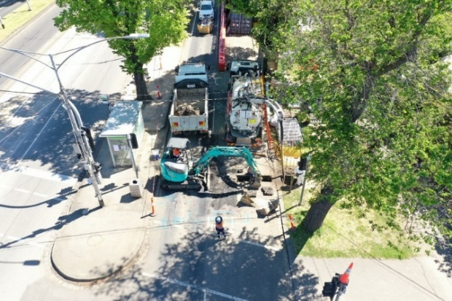
We asked for feedback about:
  - Traffic, noise and vibration modelling to inform construction hours.
  - How people move around the area.
  - Timing around the football season and other authority works.
  - Location of our site compounds.
  - Road and car park closures.
  - Input into bicycle diversions through consultation with Bicycle Network Victoria.
What was the outcome?
  - Works were scheduled to avoid peak times and reduce traffic impacts.
  - The construction program was adjusted to accommodate key dates and reduce impact to places and people.
  - The location of the site compound was negotiated with stakeholders.
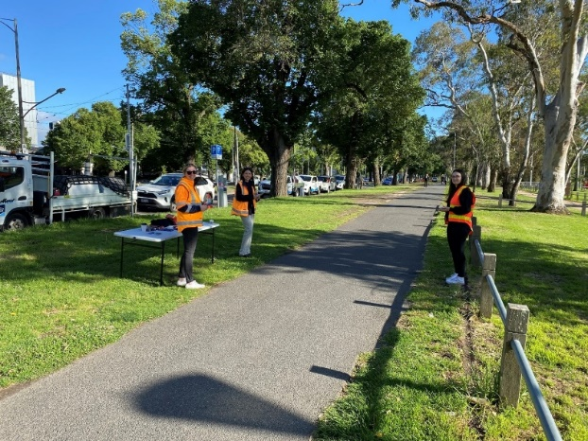
  - The cycling community understood the impacts of the construction works, and where cycling routes were diverted.
How did we engage with communities?
  - Printed notifications
  - Social media and print media
  - Web updates and YourSay page
  - Formal briefings to stakeholders
  - Door knocks
  - Pop up sessions for community to ask questions.
Contact us
Visit: yoursay.gww.com.au/engagementframework
Email: engagement@gww.com.au

gww.com.au

